Allow Absence Recording by Specific Admin Users
By: Shubham Badgujar
Introduction
A little strange it may sound first time but there are business use case where-in we want to have an absence type which should allow absence recording only if done via some specific users. Those users will be able to apply the absence for everyone but no-one else should be able to record absence apart from them.
The delivered application functionality categorises users into:
a) Employees
b) Line Managers
c) Administrators
But any further bifurcation isn’t delivered. This essentially means that an absence type can be enabled only for Administrators but we cannot restrict this to ensure that only ADMIN1, ADMIN2 can record absence against it but not all other Administrators.
In this post, we would demonstrate how we can achieve this functionality through a custom solution. So, let’s get started.
Worked Out Example
We would have to perform a series of setups to achieve this functionality. We can break them down into the following steps:
1) Create Absence Type
2) Create a Custom Profile Option (Assign Values to Specific Admin Users) 3) Create a Custom Table Value Set
4) Create a Custom Error Message
5) Create a Custom Fast Formula of Global Absence Entry Validation Type 6) Attach the Custom Fast Formula to the Absence Type Created at Step 1
7) Verify Results
Create Absence Type
We will create a simple Absence Type (say “Special Leave”) and the important attribute values are mentioned in table below:
Attribute Name | Attribute Value
Effective Start Date | 01-Jan-1951
Name | Special Leave
Pattern | Generic Absence
UOM | Days
Legislative Data Group | US Legislative Data Group
Status | Active
Validation Formula | SPECIAL_LEAVE_VALIDATION
Enable Administrative Updates | Checked

Allow Absence Recording by Specific Admin Users
By: Shubham Badgujar

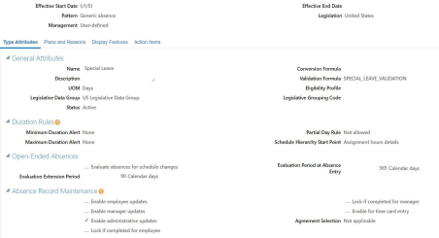
Create Custom Profile Option
We would need to create a custom profile option
(ALLOW_SPECIALLEAVE_ABSENCE_BOOKING which would hold ‘N’ at Site Level and ‘Y’ for Admin Users HCM_IMPL and HCM_IMPL1 who are authorised to record absence. All other Admin users do not have a entry here and hence they should not be able to record the absence). Details of the profile option are below:
Navigation-> Setup and Maintenance->Manage Profile Options-> Create
Attribute Name | Attribute Value
Profile Option Name | ALLOW_SPECIALLEAVE_ABSENCE_BOOKING
Profile Display Name | Allow Special Leave Absence Booking
Application | Absence Management
Module | Absence Recording
Start Date | 1/1/1951
Description | Custom Profile Option created to Allow Special Leave Absence Booking
Profile Option Level (Site) | Enabled (Checked), Updatable (Checked)
Profile Option Level (User) | Enabled (Checked), Updatable (Checked)

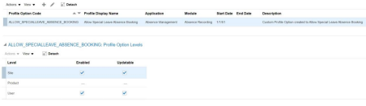
Allow Absence Recording by Specific Admin Users
By: Shubham Badgujar

Assign Profile Option Values
We will assign profile option values for this newly created profile option.
Navigation->Manage Administrator Profile Values->ALLOW_SPECIALLEAVE_ABSENCE_BOOKING
Profile Option Name: ALLOW_SPECIALLEAVE_ABSENCE_BOOKING
*Profile Level | Product Name | User Name | Profile Value
Site |  |  | N
User |  | HCM_IMPL | Y
User |  | HCM_IMPL1 | Y

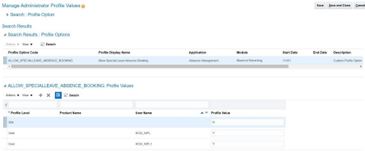
Create a Custom Table Value Set
We will now create a custom table type value set.
Navigation-> Setup and Maintenance -> Manage Value Sets -> Create
Attribute Name | Attribute Value
Value Set Code | SPECIALLEAVE_RECORDING_AUTH_VS
Description | Custom Table Type Value Set which returns the profile value assigned to ALLOW_SPECIALLEAVE_ABSENCE_BOOKING
*Module | Absence Management
Validation Type | Table
Value Data Type | Character
*FROM Clause | fnd_profile_option_values fpov , fnd_profile_options_b fpob
*Value Column Name | fpov.profile_option_value
ID Column Name | fpov.profile_option_value
WHERE Clause | fpov.profile_option_id = fpob.profile_option_id  and fpob.profile_option_name =  'ALLOW_SPECIALLEAVE_ABSENCE_BOOKING'  and fpov.level_value =fnd_global.user_guid

Allow Absence Recording by Specific Admin Users
By: Shubham Badgujar

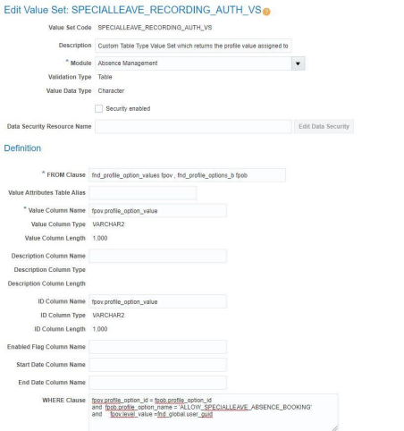
Create Custom Error Message
We would now create a custom error message.
Navigation-> Setup and Maintenance->Manage Messages -> Create
Attribute Name | Attribute Value
Message Name | SPECIAL_LEAVE_ABS_RCD_AUTH_ERR
Application | Absence Management
Module | Absence Recording
Message Number | 9000001
Message Type | Error
Severity | High
Logging Enabled | Checked
*Short Text | You are not authorized to record this absence. Please contact your system administrator.

Allow Absence Recording by Specific Admin Users
By: Shubham Badgujar

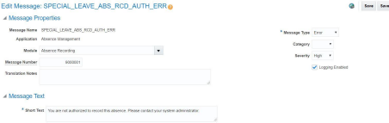
Create Custom Fast Formula
We would now create a custom Fast Formula of Global Absence Entry Validation Type. Navigation-> Setup and Maintenance-> Fast Formulas -> Create
Fast Formula Text
/* Formula Name: SPECIAL_LEAVE_VALIDATION
Formula Type: Global Absence Entry Validation
Description : Custom Global Absence Entry Validation Attached to Special Leave Absence Type Change History:
*************************************************************************************** Version Date Created By
1.0 18-May-2020 Shubham Badgujar
**************************************************************************************** */
INPUTS ARE IV_START_DATE (date),
IV_END_DATE (date),
IV_ABSENCE_REASON,
IV_TOTALDURATION

lc_valid = 'Y'
lc_val_set_has_val = 'Y'
lc_auth_val = GET_VALUE_SET('SPECIALLEAVE_RECORDING_AUTH_VS')
IF ISNULL(lc_auth_val) = 'N'
THEN
(
lc_val_set_has_val = 'Y'
lc_auth_val = 'N'
)
L_LOG = ESS_LOG_WRITE('Value of lc_auth_val is: ' || lc_auth_val)
L_LOG = ESS_LOG_WRITE('Value of lc_val_set_has_val is: ' || lc_val_set_has_val) VALID = lc_valid
IF (lc_auth_val = 'N')
THEN
(
VALID = 'N'
ERROR_MESSAGE = 'SPECIAL_LEAVE_ABS_RCD_AUTH_ERR'
RETURN VALID,ERROR_MESSAGE
)
RETURN VALID

Allow Absence Recording by Specific Admin Users
By: Shubham Badgujar

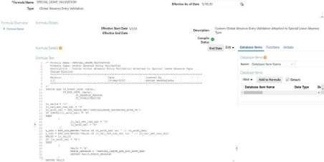
Assign Validation Fast Formula to Absence Type
Now we will attach the Fast Formula to Absence Type
Navigation->Setup and Maintenance -> Manage Absence Types -> Special Leave
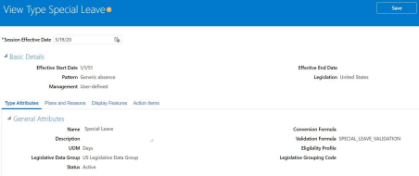
Verifying Results
Now we will login with an ADMIN user (HCM_IMPL2) who is not allowed to record absence booking for “Special Leave” and check result.

Allow Absence Recording by Specific Admin Users
By: Shubham Badgujar

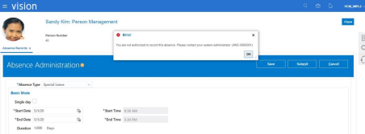
We will now login with another ADMIN user (HCM_IMPL1) who is authorized to record the absence and verify result.
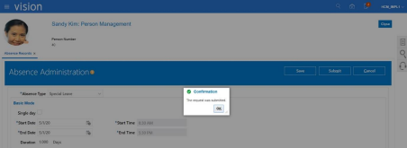

Summary
So, this is how we can make use of Global Absence Entry Validation Fast Formula to restrict absence booking for specific users. While in this example we have used controls on Admin users the same logic can very well be applied for line managers and employees too.
And with this I would end this post.
Hope this was a good read, Thanks all for your time and have a nice day ahead.

